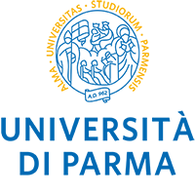

9th EAAE PhD WORKSHOP
Parma, 2022 June 22-24

Extended abstract- Research Project
(Contributed paper: minimum 1,000 words; maximum 1,500 words)

Title

First author N.¹, Second author N.² and Other coauthor N.¹ (Times New Roman, 11)
¹ Institution/Department, Affiliation, City, Country (Times New Roman, 10)
² Institution/Department, Affiliation, City, Country (Times New Roman, 10)

Introduction

Research questions

Data and research methodology

Expected results

Essential references

